PROGRAM 6

Create a package CIE which has two classes- Student and Internals. The class Personal has members like usn, name, sem. The class internals has an array that stores the internal marks scored in five courses of the current semester of the student. Create another package SEE which has the class External which is a derived class of Student. This class has an array that stores the SEE marks scored in five courses of the current semester of the student. Import the two packages in a file that declares the final marks of n students in all five courses.

package CIE;

public class Student{

    protected String usn;

    protected String name;

    protected int sem;

    public Student(String usn, String name, int sem) {

        this.usn = usn;

        this.name = name;

        this.sem = sem;

    }

    public String displayStudentInfo() {

        return "USN: " + usn + ", Name: " + name + ", Semester: " + sem;

    }

}

package CIE;

public class Internals extends Student {

    private int[] internalMarks; // Array to store internal marks for 5 courses

    public Internals(String usn, String name, int sem, int[] internalMarks) {

        super(usn, name, sem);

        this.internalMarks = internalMarks;

    }

    public int[] getInternalMarks() {

        return internalMarks;

    }

}

package SEE;

import CIE.Student;

public class External extends Student {

    private int[] seeMarks; // Array to store SEE marks for 5 courses

    public External(String usn, String name, int sem, int[] seeMarks) {

        super(usn, name, sem);

        this.seeMarks = seeMarks;

    }

    public int[] getSeeMarks() {

        return seeMarks;

    }

}

import CIE.Internals;

import SEE.External;

import java.util.Scanner;

class FinalMarks {

    private Internals internals;

    private External external;

    private int[] finalMarks;

    public FinalMarks(String usn, String name, int sem, int[] internalMarks, int[] seeMarks) {

        this.internals = new Internals(usn, name, sem, internalMarks);

        this.external = new External(usn, name, sem, seeMarks);

        this.finalMarks = calculateFinalMarks();

    }

    private int[] calculateFinalMarks() {

        int[] finalMarks = new int[5];

        int[] internalMarks = internals.getInternalMarks();

        int[] seeMarks = external.getSeeMarks();

        for (int i = 0; i < 5; i++) {

            // Assuming final mark is (internal mark) + (SEE mark scaled to 50%)

            finalMarks[i] = internalMarks[i] + (seeMarks[i] / 2);

        }

        return finalMarks;

    }

public void displayFinalMarks() {

        System.out.println(internals.displayStudentInfo());

        System.out.print("Final Marks: ");

        for (int mark : finalMarks) {

            System.out.print(mark + " ");

        }

        System.out.println();

    }

}

public class Main1 {

    public static void main(String[] args) {

        Scanner s = new Scanner(System.in);

        System.out.print("Enter number of students: ");

        int n = s.nextInt();

        s.nextLine();

        FinalMarks[] students = new FinalMarks[n];

        for (int i = 0; i < n; i++) {

            System.out.print("Enter USN: ");

            String usn = s.nextLine();

            System.out.print("Enter Name: ");

            String name = s.nextLine();

            System.out.print("Enter Semester: ");

            int sem = s.nextInt();

            int[] internalMarks = new int[5];

            int[] seeMarks = new int[5];

            System.out.println("Enter Internal marks for 5 courses:");

            for (int j = 0; j < 5; j++) {

                internalMarks[j] = s.nextInt();

            }

            System.out.println("Enter SEE marks for 5 courses:");

            for (int j = 0; j < 5; j++) {

                seeMarks[j] = s.nextInt();

            }

            students[i] = new FinalMarks(usn, name, sem, internalMarks, seeMarks);

            s.nextLine();  // Consume newline

        }

        System.out.println("\nFinal Marks of Students:");

        for (FinalMarks student : students) {

            student.displayFinalMarks();

        }

    }

}

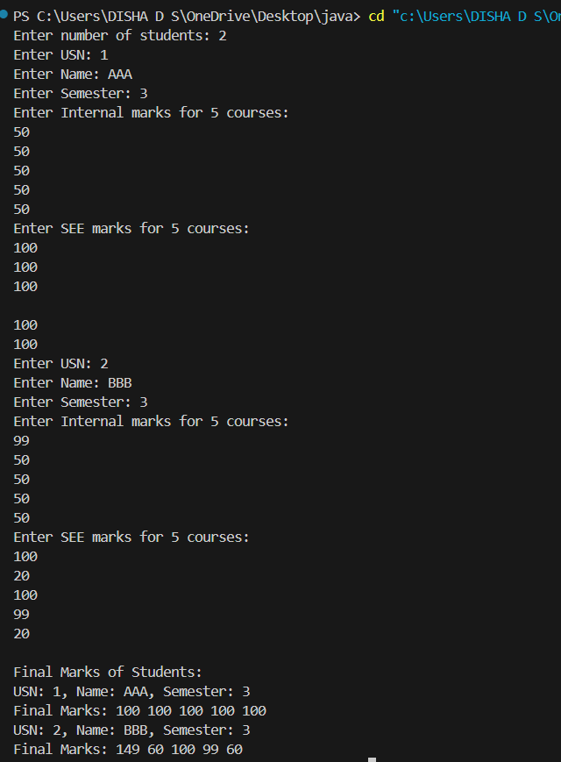OUTPUT